ASR 3645 – Pick Task By date
Date: 2012-07-23

WMS:

REPORT-> Pick Task By Date

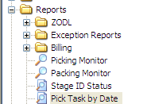

Retrieve by range of Released Date
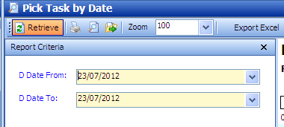

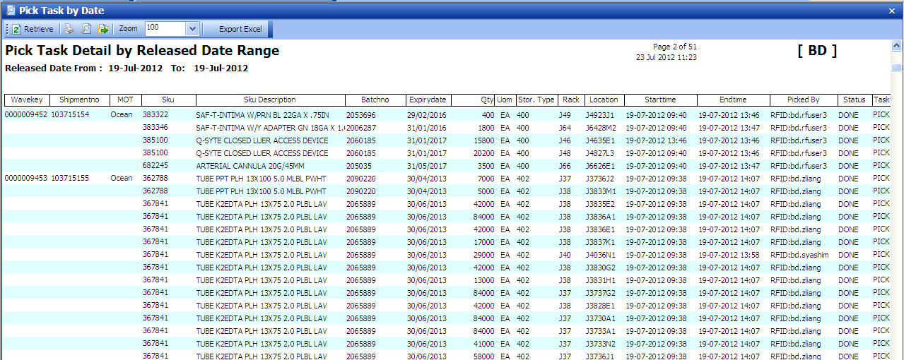

Sample output in excel:
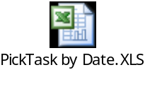

<End of Document>

